**Project Design**

**Phase -1 Solution Architecture**

|  |  |
| --- | --- |
| Date | 16 October 2022 |
| Domain Name | Internet of Things (IoT) |
| Project Name    Team ID | **Smart Solutions for Railways**  PNT2022TMID28701 |

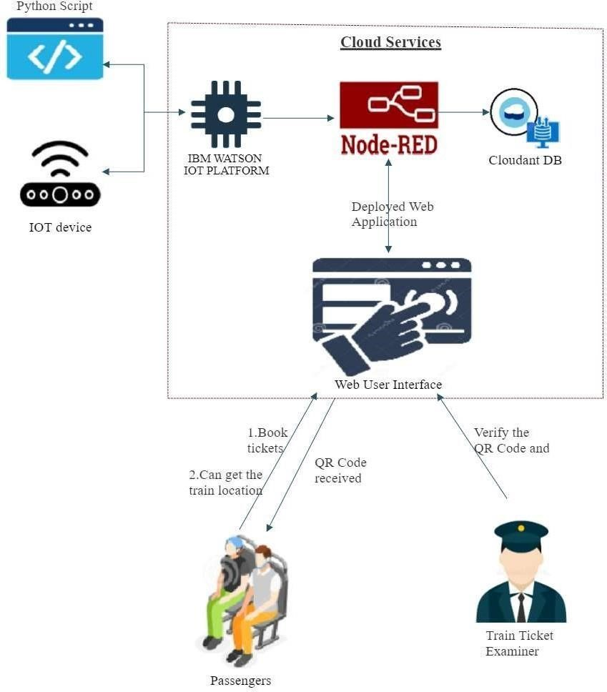**Solution Architecture:**